Sensitivity Analysis of the Three Microphone Audio Localization System
Vladyslav Nepriakhin | 5189969
Aleksey Kapustjonoks | 5267870

Design requirement and method selection
The system must point towards a sound source, which is the speaking person head. The sound source was modelled as a 0.16m wide target. From 3 meters, it occupies only 1.528°. Therefore the angular error must be smaller than this threshold, for a system to “hit” the target.
For the determination of delta t between our microphones two main methods has been considered
Integer Cross-Correlation(ICC): ESP32 is sampling at 48kHz which is 20.83us for one sample. Calculations conclude that for microphones separated by 20cm, delay creates an angular step of about 2.05°. This resolution is larger than 1.528° target, this concludes that ICC is not following the delay change smoothly, so this method fails accuracy requirement for audio localization system.
Fast Fourier Transform(FFT) Phase: When FFT method is performed, the phase difference is measured within a signal period, so we are no more dependent on sampling time. This approach provides smooth and accurate delay calculations.
ICC and FFT Phase were modelled and compared in MATLAB using the complete vertical triangular array, a 130 Hz sound source, 30° rotation and the same geometry. Comparison results show that at 40° and 3m, ICC gives roughly 2.1° error, which fails 1.528 head requirement, while the FFT phase shows more accurate response of 0.6°. (See Figure 1) It is also visible from the graph that at 70° FTT is approximately at the head-limit boundary, at 80° it exceeds the limit. Therefore FFT phase is selected as method to determine delta T between microphones, and 70° is the boundary of tested operational range.
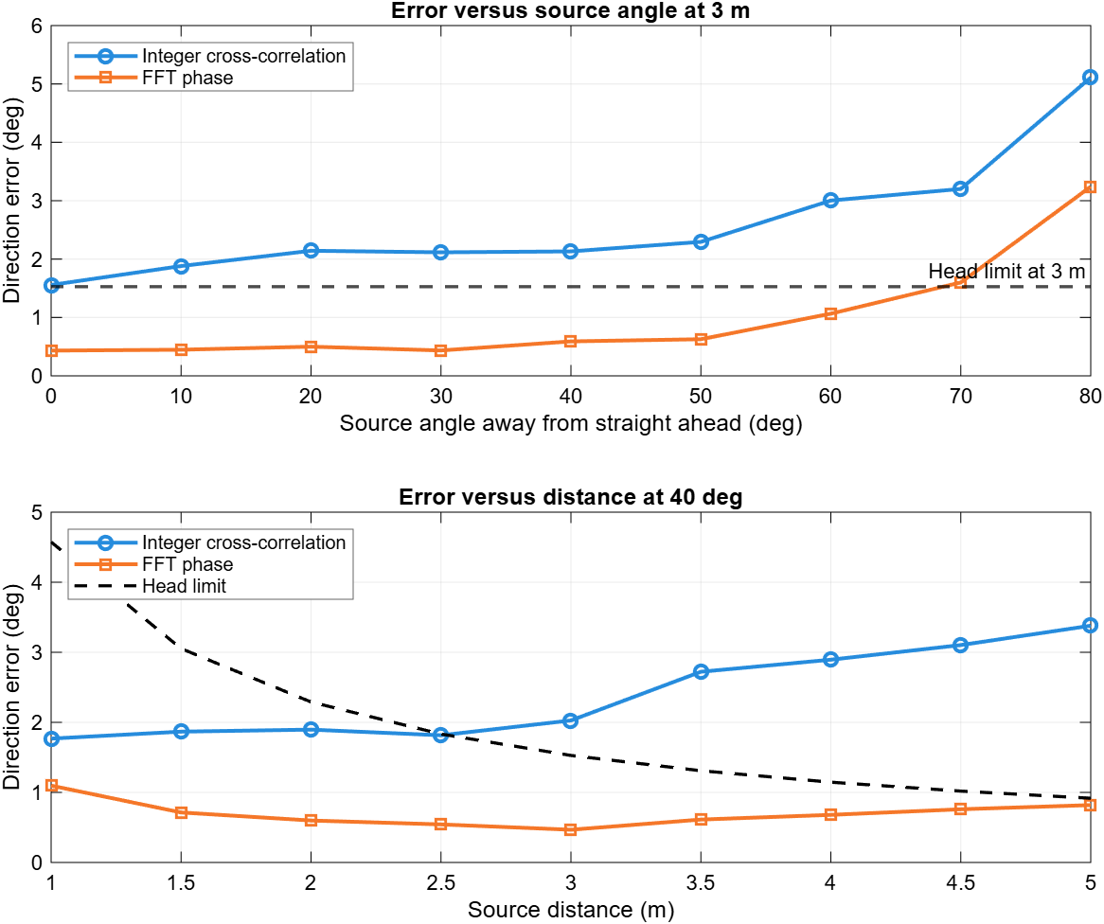
Figure 1: ICC/FFT phase comparison
This simulation also gives us answer to the question: What is the minimal change we can measure.

Simplified model of the complete system
Three omnidirectional microphones arranged in a flat, equilateral triangle spaced 20 cm(d) apart and facing forward to listen to the space directly in front of them. Because microphone array forms a equilateral triangle, angle between the microphones is 60°. Therefore, the microphones positions are defined as following ->
$$→m₁ = \left[-\frac{d}{2}, -\frac{\sqrt{3d}}{6}, 0\right], m₂ = \left[\frac{d}{2}, -\frac{\sqrt{3d}}{6}, 0\right], m₃ = \left[0,\frac{\sqrt{3d}}{3}, 0\right]$$
For source position p and microphone position mᵢ, the exact model calculates path length rᵢ, arrival time τᵢ and phase difference φᵢⱼ. Here c = 343 m/s and f is the dominant FFT frequency.
$$rᵢ = \left\|p - mᵢ\right\|, τᵢ =\frac{rᵢ}{c}, φⱼᵢ = -2πf\left(τⱼ - τᵢ\right)$$
The FFT provides φ₂₁, φ₃₁ and φ₃₂ in radians using angle (Xⱼ·conj(Xᵢ)). 3 microphone pairs form 3 differences, 2 of them are independent, these provide information about the vector and 1 is dependent and used to smooth out the measurement in case of minor errors. The final far-field equation below directly converts all three phases into the unit direction vector. The positive square root selects the front hemisphere.
$$uₓ =\frac{c\left(2φ_{21}+ φ_{31}- φ_{32}\right)}{6πfd}, uᵧ =\frac{c\left(φ_{31}+ φ_{32}\right)}{2πf\sqrt{3d}}$$
$$û = \left[uₓ uᵧ \sqrt{1 - uₓ^{2}- uᵧ^{2}}\right]ᵀ, horizontal = atan2d\left(uₓ,u_{z}\right), vertical = atan2d\left(uᵧ,u_{z}\right)$$
This is the final direction calculation used by the estimator. It does not provide absolute distance since we have 3 microphone array and only 2 independent pairs. To see TDOA math and angle calculation method please refer to the System Design document.
Sensor characteristics
Signal conditioning includes ADC and bandpass filter integrated in INMP441 microphones, signal is then passed via I2S and sampled at 48kHZ, for more details please see System Design document. Each frame is filtered to 80-200 Hz, embedded algorithm on ESP32 applies FFT to find dominant frequency among this range and find the phase difference for all 3 pairs.
The formula to for one pair is $→φ ≈\left(\frac{2πfd}{c}\right)\sin{θ,} derive with respect to angle theta- S_{φ} =\frac{∂φ}{∂θ} ≈ \left(\frac{2πfd}{c}\right)cos θ→ then sensitivity for the whole system is→ S_{q} = \left\|\frac{∂\left[φ_{21}φ_{31}φ_{32}\right]ᵀ}{∂q}\right\|$, where d – distance between microphones(20cm), c – speed of sound(343m/s), $fd$ is the dominant frequency and $sin(θ)$ he physical angle of the sound source. The sound waves move across the room, so physical geometry of the sound source is always changing, making the system non-linear. Angl function does not change direction, note that sensitivity is positive and stays positive, across all operational range – meaning that the sensor is monotonic. It is also important to mention that FFT phase approach can in introduce the system wrapping, the wrapping frequency is described by -> $f_{\text{wrap}}=\frac{c}{2d}$-> $f_{\text{wrap}}=\frac{343}{2×0.20}=857.5 \text{Hz}$.(See space wrapping in the table below)
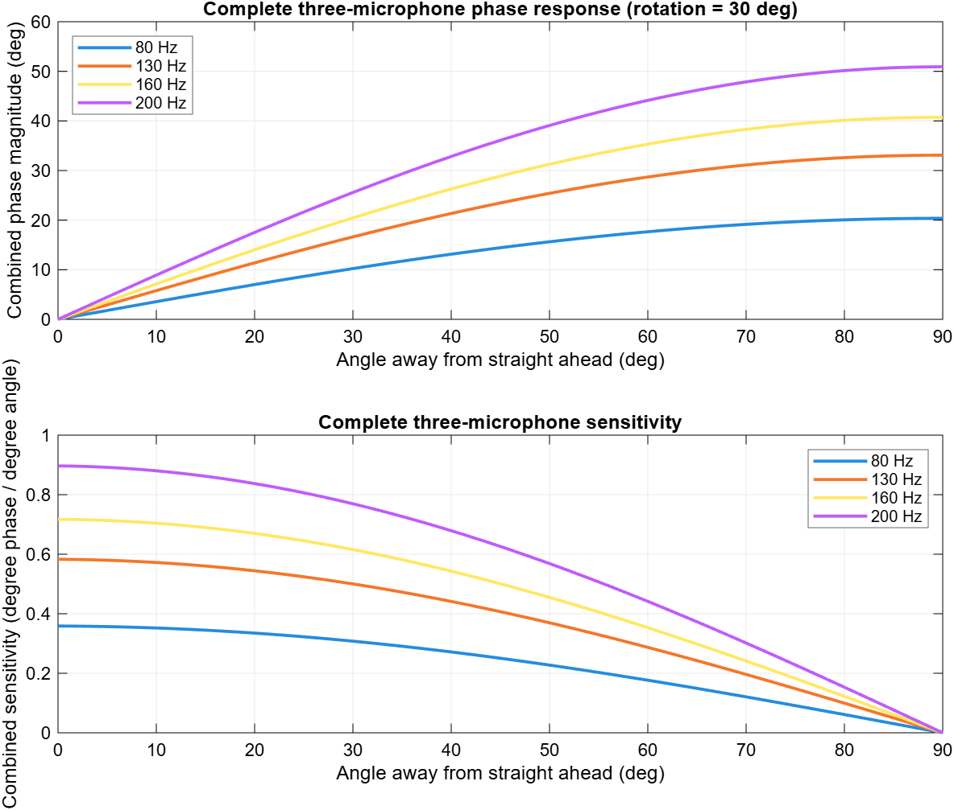  Figure 2: Sensitivity for different frequencies |  | Figure 3: Full 3 microphone sensitivity map
Characteristic | Result from the model
Sensitivity | Degrees of combined phase per degree of source angle. It shows how precisely a small direction change appears in the phases; it is not angular resolution by itself.(See the angular resolution in System Design)
Monotonicity | Along a fixed horizontal or vertical sweep, phase magnitude changes monotonically. Full 3D direction requires two independent phase differences; sensitivity stays positive across the operational range.
Linearity | The response follows sin(θ), so the full range is nonlinear. It is nearly linear within approximately ±20°, where the sine approximation differs by less than 2%. It is also changing depending on $fd$
Maximum / minimum | Maximum complete-system sensitivity occurs at 0°: 0.359, 0.583, 0.717 and 0.897 degree/degree at 80, 130, 160 and 200 Hz. It falls to 0 at 90° in this angular slice.(See Figure 2)
Frequency $fd$ | Sensitivity is proportional to frequency. Therefore 200 Hz produces 2.5 times more phase change than 80 Hz for the same angle change.
Angular range | At 3 m, the FFT result at 70° is approximately at the 1.528° head-limit boundary, while the error at 80° clearly exceeds it. Therefore 70° is selected as the boundary of the tested operating region.
Distance range | The comparison covers 1-5 m at 40°. FFT phase stays below the head limit in this sweep, but the intended use remains 2-3 m. Note that these simulated distances are not physical minimum and maximum detection distances.
Spacing / phase wrap | Sensitivity is proportional to spacing d. With d = 0.20 m, maximum single-pair phase is 41.98° at 200 Hz, safely below 180°, so phase wrapping does not occur in the selected band.

